To implement the BL_DM level loading process, I created one procedure for inserting Default Rows into tables. I also created procedures on BL_CL (one procedure = one dimension) to load dim data into the DM layer. For each dimension I created a composite type (for example, TYP_DIM_CUSTOMERS). Each procedure uses EXECUTE for dynamic queries and cursor variables. I also uses the INSERT ... ON CONFLICT (business_key) DO UPDATE (Upsert) clause, which ensures that when the procedure is re-run with the same data, no new records are created, and existing records are updated only if there are changes. This is confirmed by the rows_affected = 0 value in the logging table during the second run. To ensure ON CONFLICT works correctly, I added Unique Constraints, as I didn't add them when creating the tables in the previous task (I've added the code to the SQL file for this task).
Repeatability is implemented through a WHERE NOT EXISTS check on business keys (SRC_ID + SOURCE_SYSTEM). Procedures are created via CREATE OR REPLACE. I also added an Exception block to each procedure. Any error is logged to MTA_LOGGING with the 'ERROR' status. All operations (BL_3nf and BL_DM layers) are recorded in a single table, MTA_LOGGING. Each record contains the procedure name, execution status, and the exact number of affected rows.

Test results:
First run: All dimensions were successfully populated. Logs confirm insertion of records (rows_affected > 0).
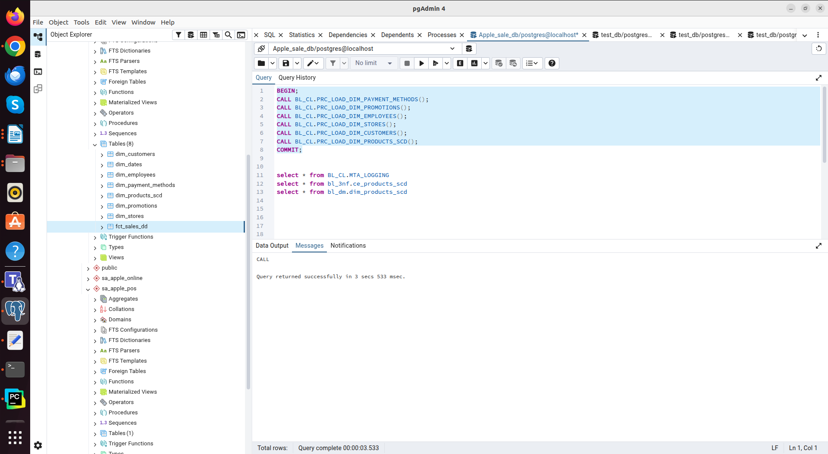

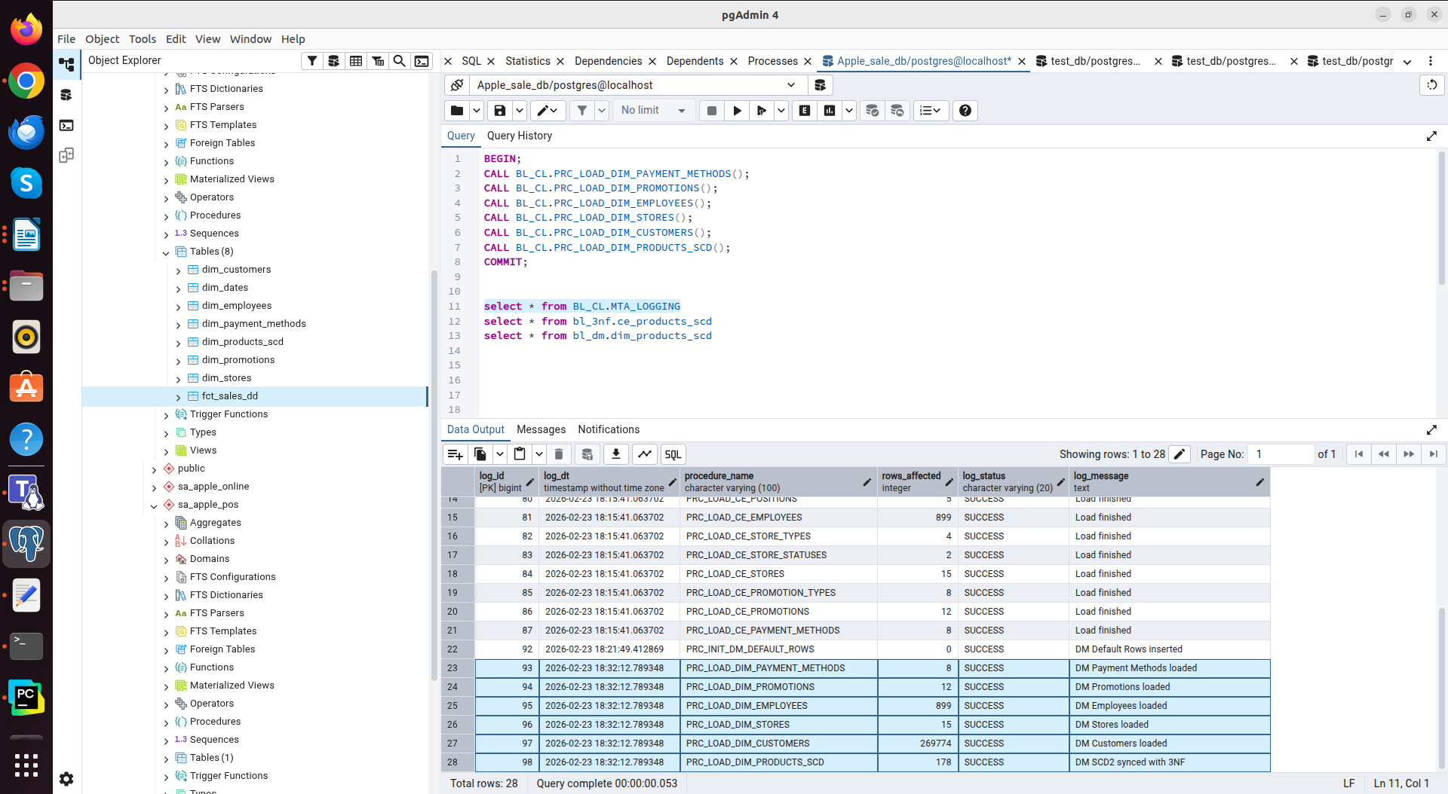

Second run: All procedures completed successfully, confirming the absence of duplicates (rows_affected = 0).
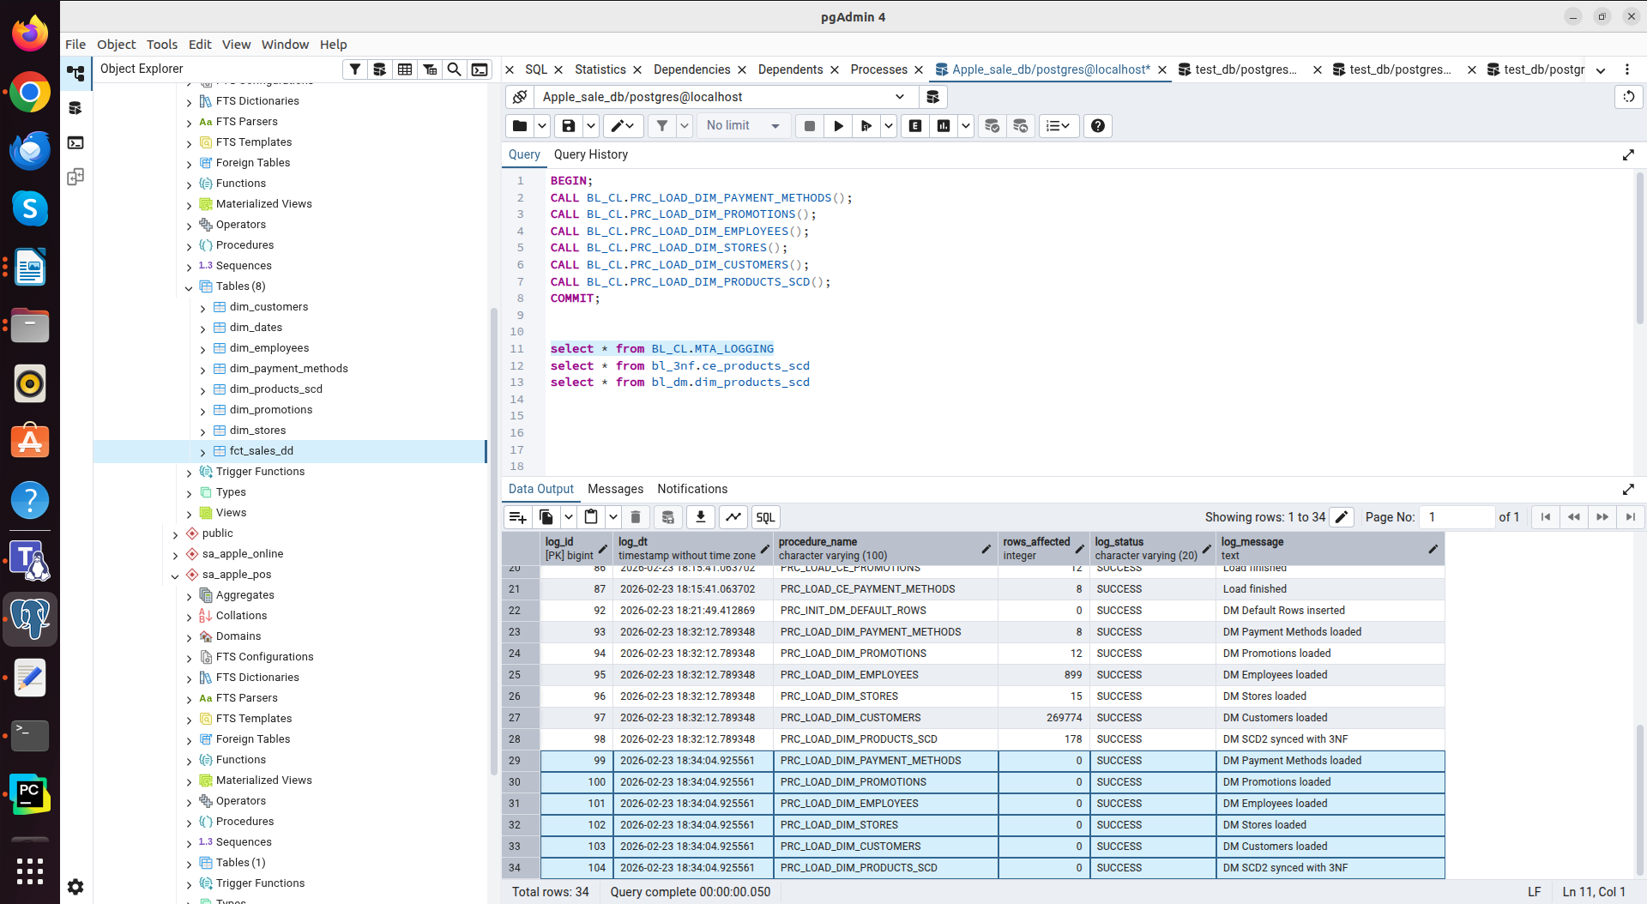

For example, the data loaded into the table BL_DM.DIM_STORES
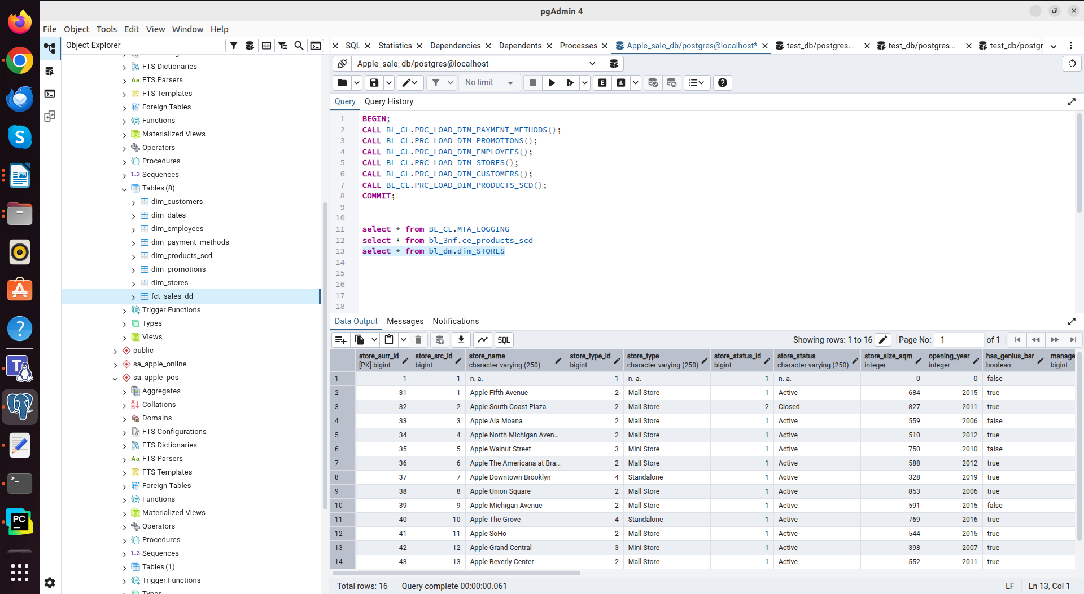

The SCD2 logic was successfully tested: when the product color (iPhone 14 Plus color was changed from Blue to Deep Blue) was changed in the CSV file, the procedure correctly identified the changes. The old version of the record was deactivated (closed with the end date), and a new version was created with the current data. The data was changed correctly on both storage layers (3NF and DM).

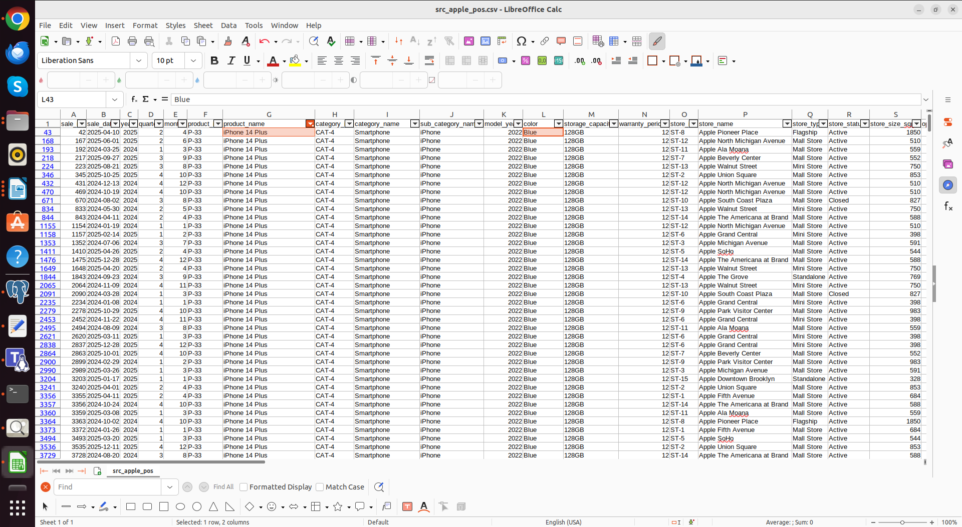
Before (Blue)
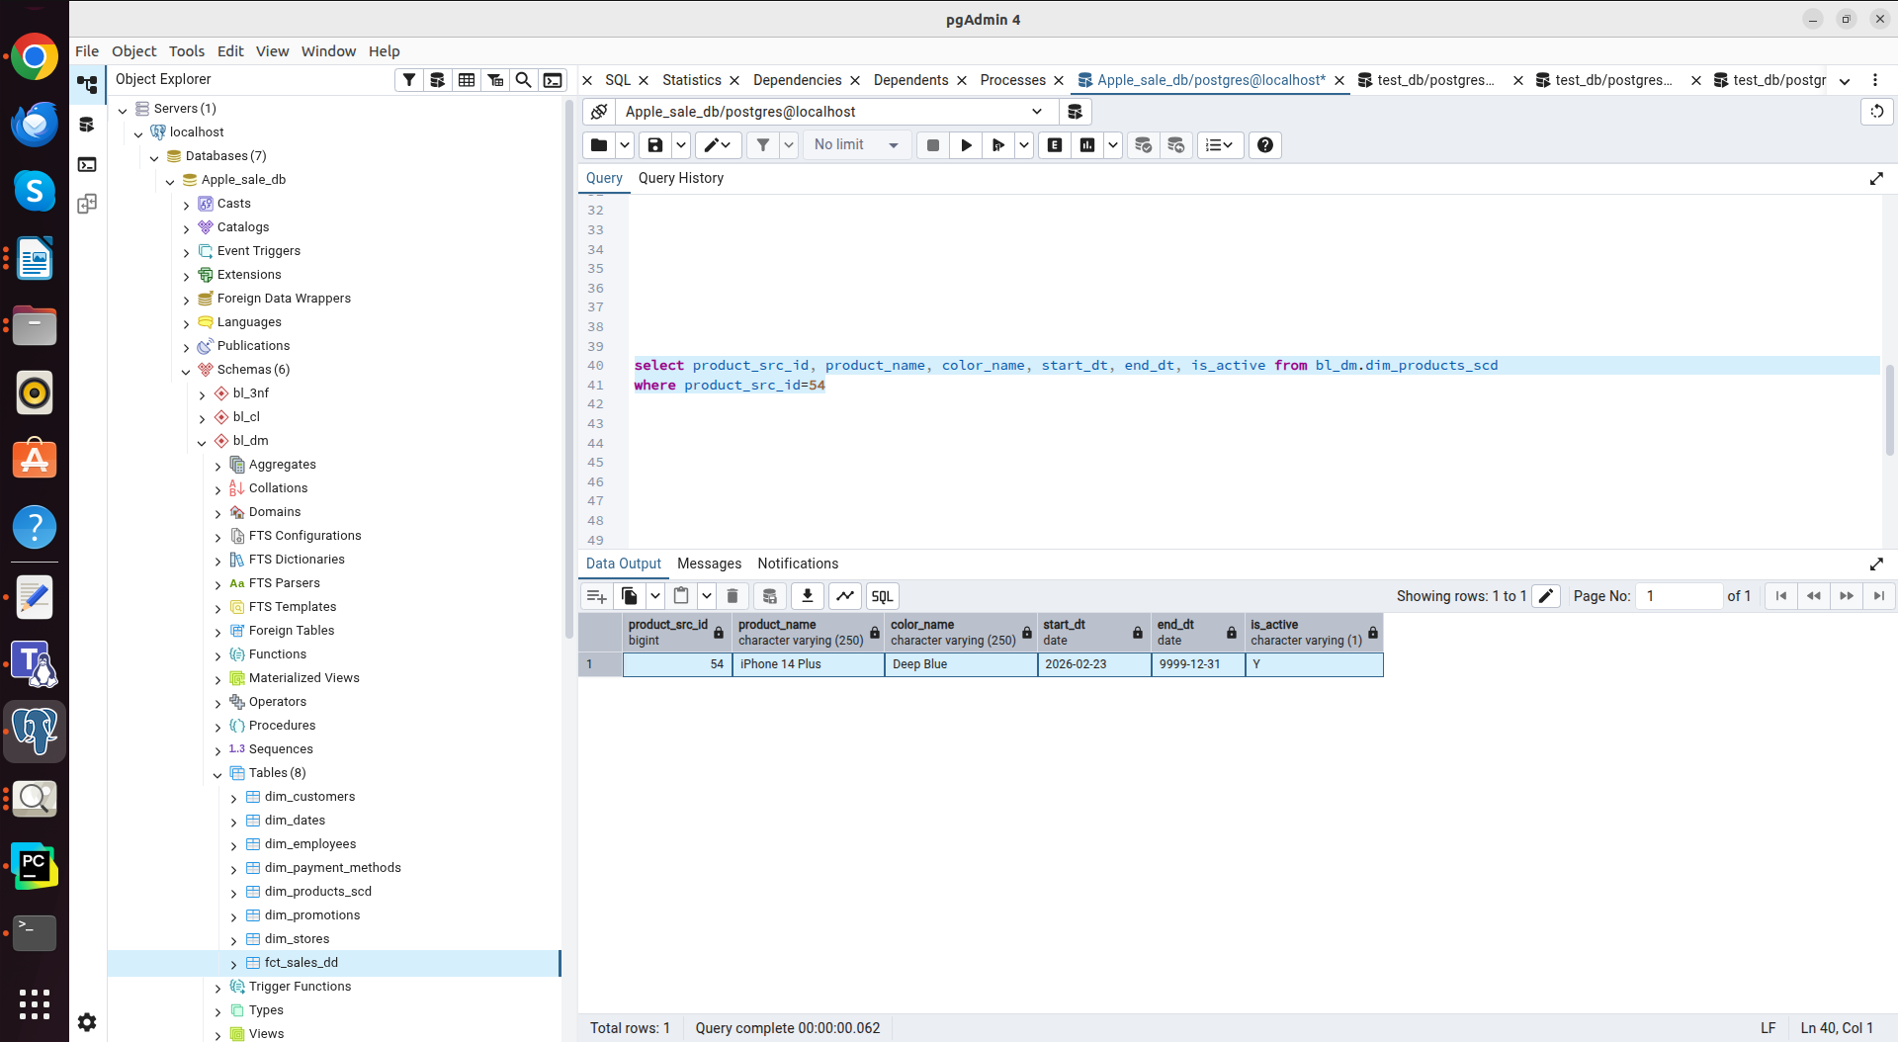

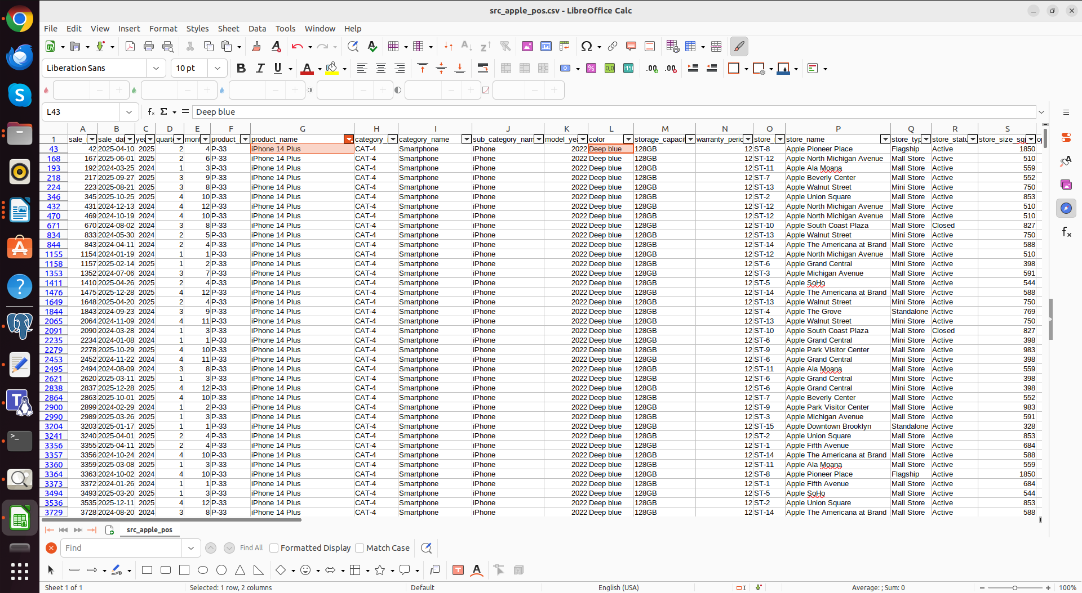
After (Deep Blue)

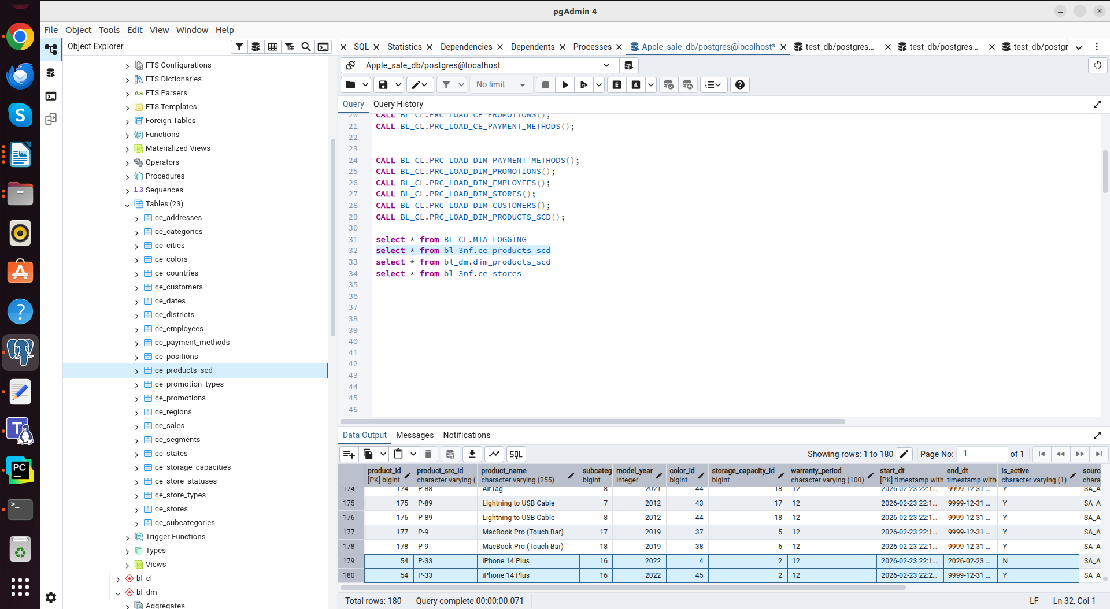
BL_3NF

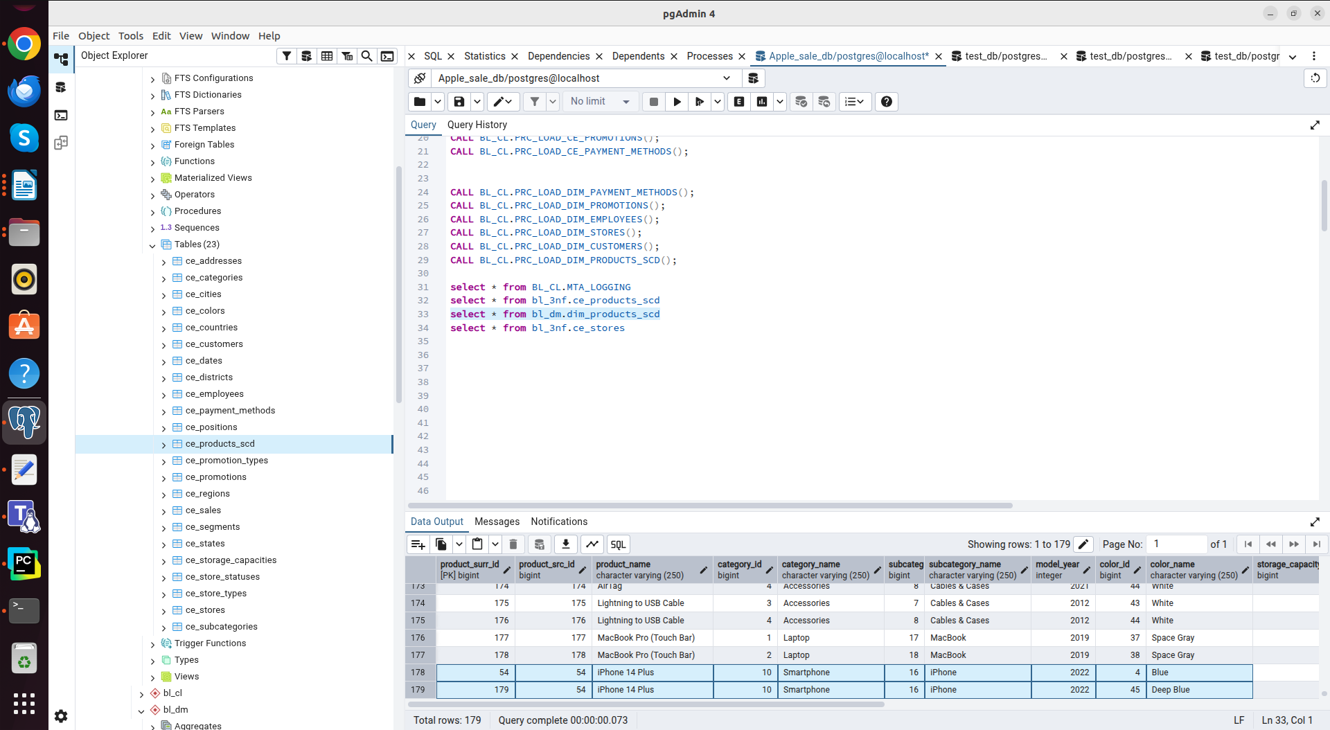
BL_DIM

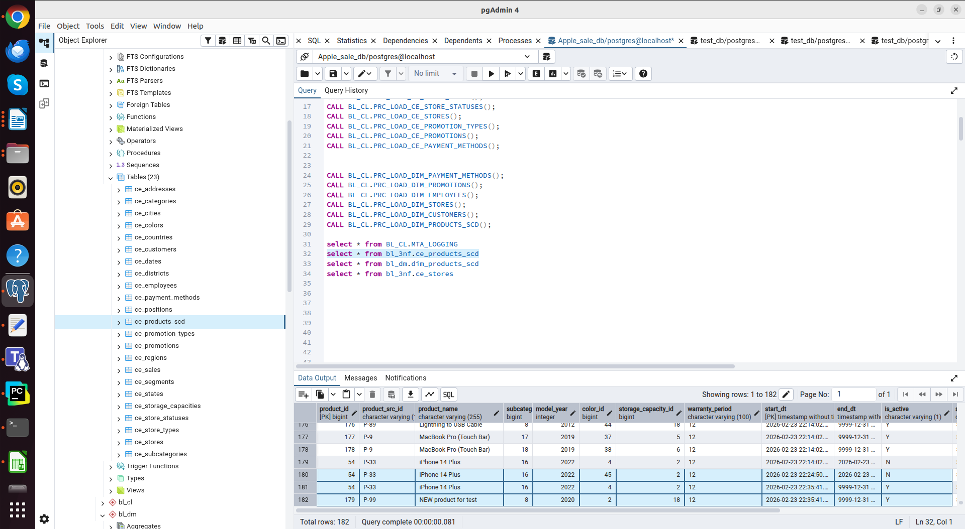
Changed the color back to blue. Added a new product for testing. (BL_3NF)

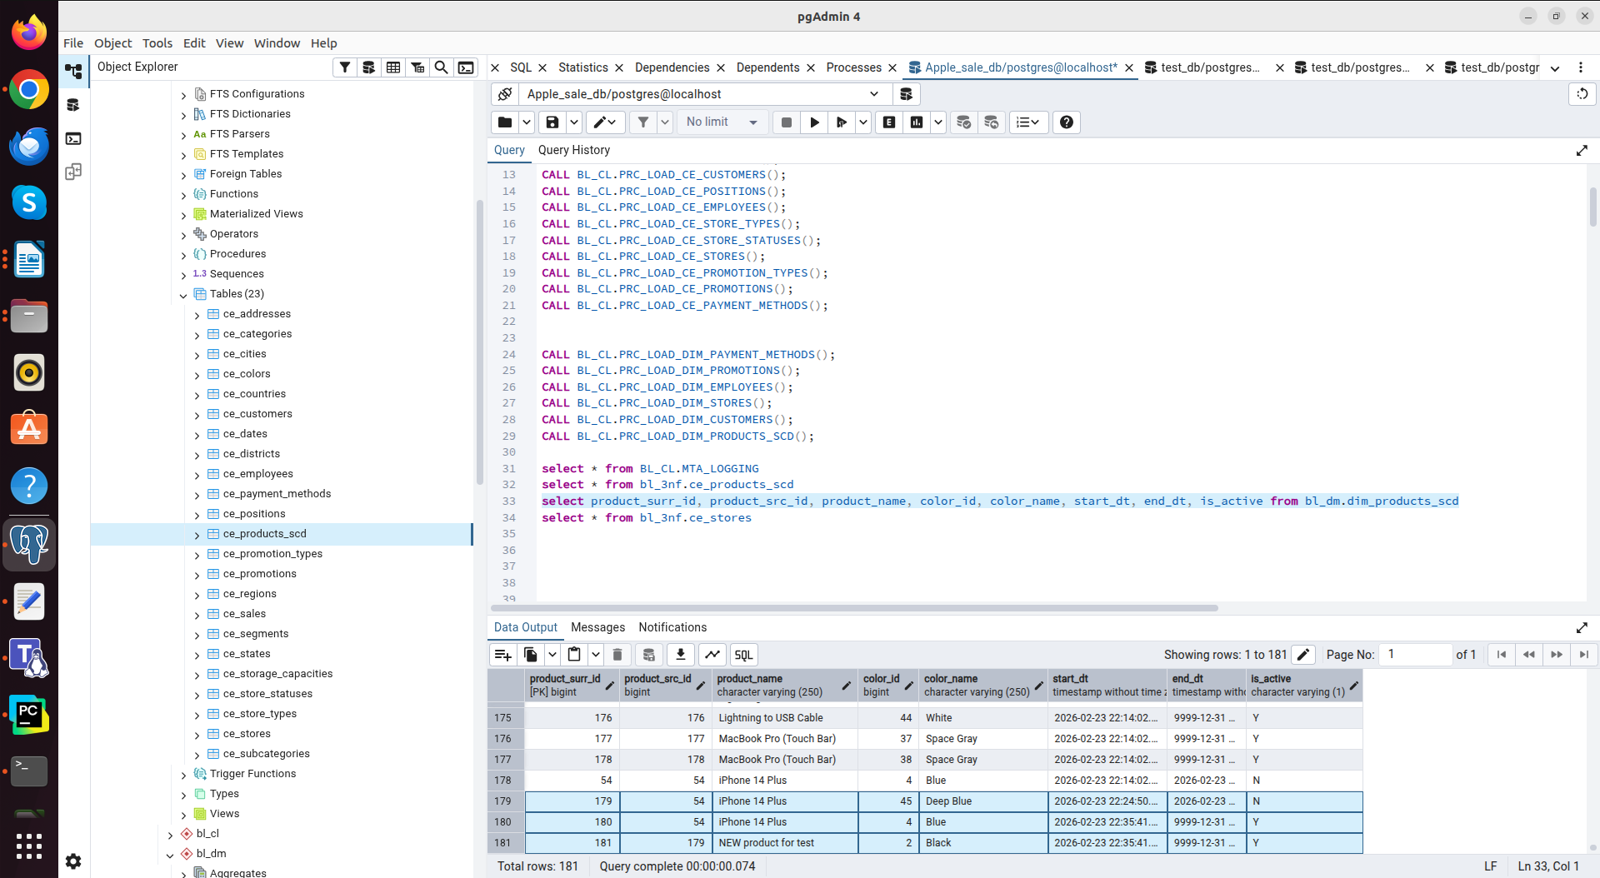
Changed the color back to blue. Added a new product for testing. (BL_DM)

